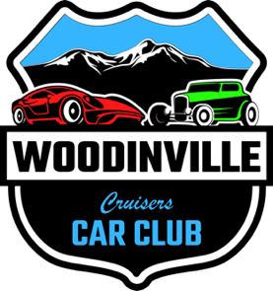

Participant Disclosure
Rules & Regulations, Disclaimer, and Waiver of Liability:

Participation in this event, including but not limited to showing at, participating in, purchasing items from, or attending the Car Show / Cruise / Parade / Festival / Event, is entirely at your own risk. By participating, you acknowledge and accept this risk.

The Woodinville Cruisers Car Club, its members, event coordinators, agents, officers, officials, staff, volunteers, sponsors, vendors, the Woodinville Chamber of Commerce, and the City of Woodinville, including its departments, agents, officers, elected and appointed officials, and volunteers, will not be liable for any damages, loss of property, or injury of any degree. By attending, you agree not to hold any of these entities or individuals liable for any damage, loss, injury, or other incidents you, your property, or your guests may sustain or incur by participating in or attending this event or any related activities.

By participating in this event, you also consent to the use of any photos taken during the event for promotional purposes, including future shows, website postings, merchandise, and fundraising activities.

Interacting with or purchasing from our supporters, donors, and vendors is at your own risk. Ensure your vehicle is properly insured and that you obey all traffic laws when traveling to, from, and within the event grounds. Drive slowly and safely when entering, parking, and exiting the event areas. Be respectful of other attendees, patrons, event staff, volunteers, and surrounding neighbors.

If you use any awnings, tents, or umbrellas, make sure they are properly secured to prevent accidents in case of sudden weather changes. Use your best judgment and prioritize safety. If it is windy, refrain from setting up items like awnings, tents, umbrellas, or folding chairs that could potentially fall or be blown over, causing injury or damage.

No burnouts, racing, reckless driving, illegal substances, or rude behavior will be permitted at the event.

Licenses, registration, and insurance may be required per City / State laws. These requirements are the responsibility of the individual participant(s), vendor, and/or business.

If you notice any unsafe conditions or potential problems, notify event staff or volunteers immediately.

Event staff / volunteers reserve the right to remove any participant or attendee from the event for violating these rules or for any other reason deemed necessary to maintain the safety and integrity of the event.

By registering and/or participating for any / all events, you hereby agree to all the above terms.

Please enjoy the Event and thank you for your support!

©Woodinville Cruisers Car Club Rev. 6/24

