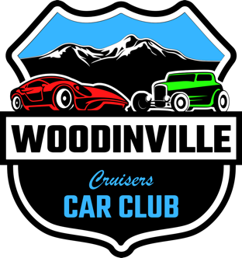

Disclaimer, Warning, and Waiver of Liability:

Participation in this event in any capacity including but not limited to Showing at, participating in, purchasing items from, or attending the Car Show / Cruise / Parade / Festival / Event is at your own risk; You knowingly and willingly do so at your own risk. Woodinville Cruisers Car Club, its members, event coordinator(s), agents, officers, officials, staff and volunteers, all sponsors, Woodinville Chamber of Commerce, and vendors as well as the City of Woodinville to include its departments, its agents, officers, elected and appointed officials, and volunteers will not be held liable for damages, loss of property, or injury of any degree. By attending the event you agree to NOT hold any of the named or anyone else associated with the event liable for any damage, loss, injury, or anything else you, your property, or your guests may sustain or incur by participating in or attending this event or any related event. By participating in the event, you agree to allow us to use photos that are taken at the event as we see fit, i.e., for possible promotion for future shows, website postings, merchandise and/or promotional items, for the current show and / or for fundraising purposes now and in the future. Visiting, interacting, or purchasing from or with our Supporters, Donors, and Vendors is at your own risk as well. PLEASE MAKE SURE YOUR VEHICLE IS PROPERLY INSURED AND YOU OBEY ALL TRAFFIC LAWS ON YOUR WAY TO, FROM, AND WHEN ON THE SHOW / EVENT GROUNDS. DRIVE SLOWLY AND SAFELY WHEN ENTERING, PARKING, AND EXITING THE EVENT AREAS. BE RESPECTFUL OF OTHERS ATTENDING THE EVENT, PATRONS, EVENT STAFF, VOLUNTEERS AND THE SURROUNDING NEIGHBORS. IF YOU HAVE ANY TYPE OF AWNING, TENT OR UMBRELLA, YOU ENSURE IT IS PROPERLY SECURED IN THE EVENT OF SUDDEN WEATHER/WIND. WE ASK YOU TO USE YOUR BEST JUDGEMENT AND THINK OF SAFETY FIRST. IF IT IS WINDY, PLEASE DO NOT PUT-UP AWNINGS, TENTS, UMBRELLAS, FOLDING CHAIRS, OR ANY OTHER DEVICE OR APPARATUS THAT COULD POTENTIALLY FALL, FLY, OR BE BLOWN OVER AND POSSIBLY INJURE SOMEONE OR DAMAGE PROPERTY. NO burnouts, alcohol, illegal substances, loud music, racing, or reckless driving or behavior will be permitted or allowed at the event.

Please enjoy the day and THANKS FOR YOUR SUPPORT! If you see an unsafe condition or notice any type of problem or potential problem, notify event staff / volunteers immediately. All vehicles and vendors must have current registration and insurance and be operated by a valid licensed individual. Guests must be able to provide a copy of these documents if requested by event staff / volunteers.

